Explosive Sum

DESCRIPTION:
In number theory and combinatorics, a partition of a positive integer n, also called an integer partition, is a way of writing n as a sum of positive integers. Two sums that differ only in the order of their summands are considered the same partition. If order matters, the sum becomes a composition. For example, 4 can be partitioned in five distinct ways:

SOLUTION:
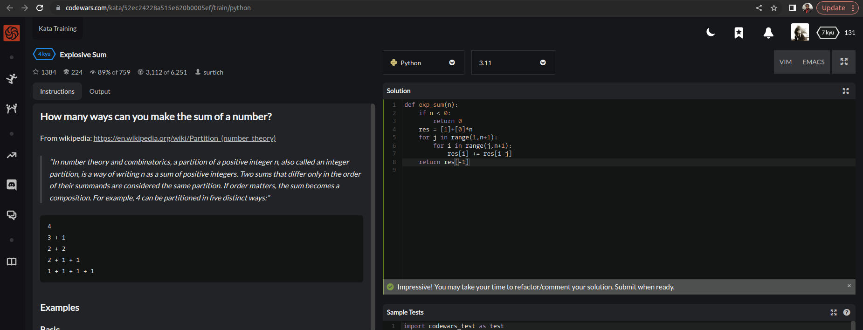

EXPLANATION:
The given function exp_sum(n) takes an integer n as input and computes the number of ways in which n can be expressed as a sum of positive integers. The variable res is initialized to a list of length n+1, where the first element is 1 and the rest are 0. The element res[i] represents the number of ways to partition i using positive integers. The outer loop of the function iterates over the integers from 1 to n, and the inner loop iterates over the integers from j to n. For each value of i, the value of res[i] is updated by adding the value of res[i-j], which represents the number of ways to partition i-j using positive integers no greater than j. The final value of res[-1] is returned, which represents the number of ways to partition n.

